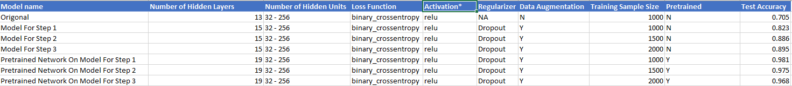

In this report I found that dropout regularization and data augmentation have a dramatic positive impact on the test accuracy of the model, as can be seen in the graph above showing about a 12% increase in test accuracy. I have theorized this is likely due to dropout regularization and data augmentation lowering the tendency of smaller models to overfit allowing for more training on the model thus improving the performance.

I also found that for non-pretrained networks increasing the training sample size improves the test accuracy with the best prediction results coming from the largest training sample size possible 2000. Which is shown in the above graph as you can see the test accuracy increase about 7% as we increase the training sample size from 1000 to 2000. This is likely due to the fact that the more images the model has to train on the closer the model is able to reflect reality.

I discovered that pretraining networks increases accuracy significantly over a model that is the same in all things but not pretrained. Also, I found that pretrained networks respond negatively to an increased training sample size with each increase in sample size decreasing the accuracy of the model. Making the smallest sample size tested at 1000 being the most accurate model.